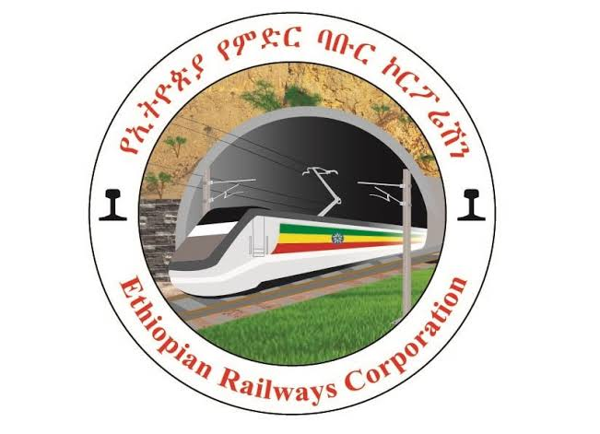

**Request for Expression of Interest Notice**

**FEDERAL DEMOCRATIC REPUBLIC OF ETHIOPIA MINISTRY OF FINANCE**

**PUBLIC-PRIVATE PARTNERSHIP DIRECTORATE GENERAL (PPP DG)**

**On behalf of Ethiopian Railways Corporation (ERC)**

**For the**

**Indode Station Logistics Port Development Public Private Partnership Project**

**13th of July, 2025**

The Federal Democratic Republic of Ethiopia, through its recent reform programs, intends to increase private sector involvement in the transport sector, which is currently limited to public and freight transport services and freight forwarding, by opening for private sector engagement in dry port and railway terminal development and logistics services. To this end, the Government has launched this Request for Expression of Interest Notice (“**REOI Notice**”) for the design, build, finance, operation and maintenance (DBFOM) of Indode Intermodal Rail Terminal and Dry Port, and Logistics Centr("**Project**").

The Project site is located in central Ethiopia, about 26 km southeast from Addis Ababa city. The site sits on the key intermodal corridor between Djibouti and Addis Ababa in proximity to Ethiopia's main consumer centre (the Greater Addis Ababa Area).

The information contained in this REOI Notice has been prepared by the Ministry of Finance Public Private Partnerships Directorate General in consultation with Ethiopian Railway Corporation solely for the purpose of assisting the recipients to this REOI Notice ("**Respondents**") in accessing the Request for Expression of Interest (“**REOI**”) and submitting an expression of interest ("**EOI**") in respect of the Project (as defined below).

This REOI does not constitute an offer in relation to the Project. The information in the REOI Notice does not purport to be all-inclusive or to contain all the information that a Respondent(s) or its advisors may require in relation to the Project. The Respondent(s) are invited to access the full REOI in accordance with the instructions set out below.

Respondents are invited to submit an EOI no later than **5:30 PM** Addis Ababa time (GMT+3 Hours) on **29th** ofAugust 2025 in accordance with the full REOI which can be accessed on the websites of the Ethiopian Ministry of Finance [**www.mofed.gov.et**] or the Ethiopian Railway Corporation [**www.erc.gov.et**], or by requesting it directly from the PPP Directorate General via email [**pppethiopiaabebeg@gmail.com /** **[agebrehiwot@mofed.gov.et](mailto:agebrehiwot@mofed.gov.et) / pppethiopiamisgina@gmail.com].**